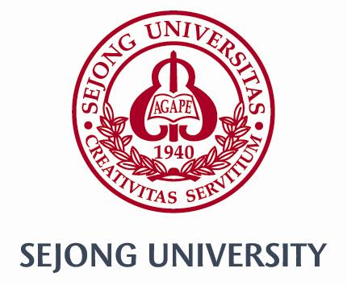

Flight Details Form

Center for International Students and Scholars at Sejong University offers an Airport Pick-up Service through VASCO. If you would like transportation from the airport to Sejong University, please contact to the VASCO.

Step 1: Please schedule your flight.

- Arrival Airports: Incheon International Airport (ICN)
- Flight Times: Exchange students arriving between the hours of 9:00am
– 4:30pm on check-in dates (Feb 25 – 26, 2015).

Step 2: Complete the below form.

Name of the Student |  | Phone
 |  | Email
Arrival Date |  | Arrival Time
Name of Airline |  | Flight #
Step 3: Submit the form.

• Please e-mail this form to the info.univ@vascoworldwide.com by Jan 22, 2016.
- Helpline call center: +82 70 4044 0545
• All students should submit the flight details whether the student will use the
VASCO’s airport pick up service or not.

